SmartCare v0.3 - Domain Model Workbook
Week 6 student resource

Requirement-to-Concept Trace
Requirement | Concept | State/behaviour | Decision
FR-01: Create a new patient record | Patient | Attributes: patient_id, name, dob, phone. Behaviour: update_contact_details() | Model as a class. Patient is a core entity.
FR-04: Create a new practitioner record | Practitioner | Attributes: practitioner_id, name, specialty. Behaviour: update_availability() | Model as a class. Practitioner is a core entity.
FR-06: Book an appointment | Appointment | Attributes: appointment_id, date, time, status. Behaviour: book() , cancel () | Model as a class. Appointment links Patient and Practitioner.
FR-07: Prevent duplicate bookings | Appointment | State: status = “Booked”.  Behaviour: is_duplicate(practitioner, date, time) | Encapsulate the duplicate-check logic within the Appointment class or a scheduling service.
FR-08: Cancel an appointment | Appointment | Behaviour: cancel() sets status = “Cancelled”. | Status is an attribute of Appointment.
FR-09: View practitioner schedule | Practitioner | Behaviour: get_schedule(date) returns a list of Appointments. | The Practitioner class collaborates with Appointment.
FR-10: View patient history | Patient | Behaviour:  get_appointment_history() returns a list of Appointments. | The Patient class collaborates with Appointment.
FR-12: Daily appointment report | Appointment | Behaviour:  Get_appointment_by_date(date)  (static/class method or repository method). | Reporting will be handled by a service or repository in later stages.

CRC Cards

Patient
Responsibilities | Collaborators
Store patient details (ID, name, DOB, phone) | Appointment
Allow updating of contact details
Provide a list of past and future appointments | Appointment

Practitioner
Responsibilities | Collaborators
Store practitioner details (ID, name, specialty) | Appointment
Manage availability schedule
Provide a list of appointments for a given day | Appointment

Appointment
Responsibilities | Collaborators
Store appointment details (ID, date, time, status) | Patient, Practitioner
Link a Patient to a Practitioner at a specific date/time | Patient, Practitioner
Prevent duplicate bookings (same practitioner, date, time) | Practitioner
Allow cancellation (change status to “Cancelled”)
Provide appointment status

Optional class: ClinicSchedule
Responsibilities | Collaborators
Coordinate the booking of appointments | Appointment, Patient, Practitioner
Check for double bookings before creating an appointment | Appointment
Generate daily reports | Appointment

UML Class Diagram
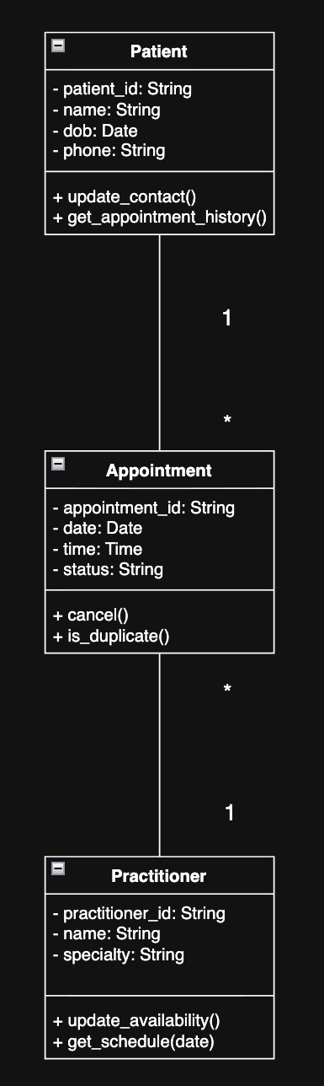

Design Rationale
Class Selection: Patient, Practitioner, and Appointment are the three main classes, and they were selected based on the fact that they are directly representative of the three main entities that the clinic has to manage. This is clearly mentioned in the case study where the client requests software that “manages patients, practitioners and appointments.
Responsibility Allocation:
- Patient is responsible for storing patient details (ID, name DOB, phone) and providing access to their own appointment history. This keeps patient data self-contained (high cohesion).
- Practitioner is responsible for storing practitioner details (ID, name, specialty) and managing their availability. This keeps practitioner data separate from patient data.
- Appointment acts as the main connecting class. The class of Appointment is the one that connects a Patient and a Practitioner on a certain date and time. This class will contain the appointment’s status which can be Booked, Cancelled, or Completed. The cancellation and duplicate logic should also be used in the same class.
Key Relationships and Multiplicities:
- Patient (1) → Appointment (*): A patient can book multiple appointments over time, but each appointment belongs to exactly one patient.
- Practitioner (1) → Appointment (*): A practitioner can see many patients, but each appointment is with exactly one practitioner.
- These are associations rather than compositions because an appointment record can still exist for historical reporting even if a patient or practitioner record is removed from the system.
- The Appointment class sits in the middle because it is the bridge between the two main actors in the clinic (patients and doctors).
Summary: This solution is not complex, it is straightforward, solving the issues that were pointed out in the case study (duplicated bookings, status inconsistencies, record search problems), without over-complicating things, It forms a good bases for further implementation stages.

Lab/Python Activity – Evidence
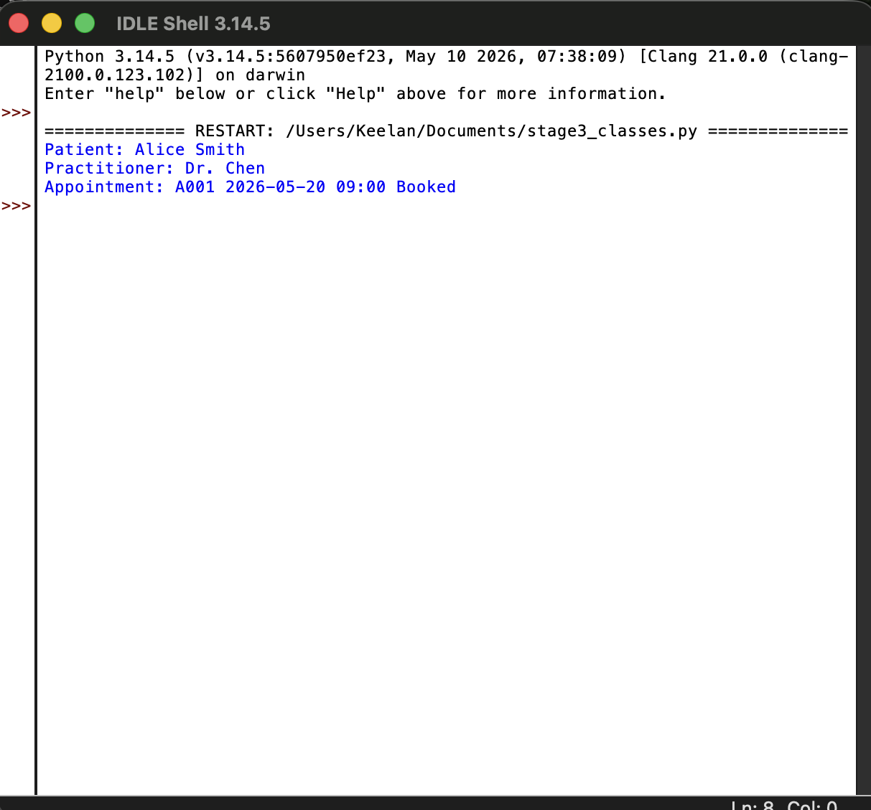
Stage 3 domain model class skeletons executed successfully via stage3_classes.py. Classes (Patient, Practitioner, Appointment) are defined with attributes and method stubs, matching the UML domain model.

AI Design Review Record
AI suggestion | Evidence | Decision | Reason | Model change
Add a TimeSlot class to represent available booking times. | FR-06 mentions booking a time slot. | Reject | For a simple clinic system, using a Date and Time attribute on the Appointment is sufficient. | No change. Kept as attributes.
Make Appointment a composition of Patient and Practitioner. | The relationship between them is strong. | Reject | Composition implies that an Appointment cannot exist without the Pateint/Practitioner. For historical reporting, we may need to keep appointment records even if a patient leaves the clinic. Association is more flexible. | Kept as association.
Add a ClinicSchedule class to manage bookings. | FR-07 (prevent duplicate) and FR-12 (reporting) require coordination. | Modify | I agree that coordinating class is useful. I have added it as an optional class in the CRC cards and will consider it for the architecture principles. | Added as optional class.
The Appointment class should not have an is_duplicate method. That should be in a service. | Separation of concerns. | Accept | Placing the duplicate check in a service | Placing the duplicate check in a service (or the ClinicSchedule class) separates the data from the business logic. This aligns with good architecture principles.

